­­­­

Name __________ Scouting For Team ______________

Regional _________________________ Match # ______

Activity During Autonomous Mode

Ratings (10 is Best)

Is This Robot Compatible With Us? Yes / No

Pyramid Goal

High Goal

Medium Goal

Low Goal

Goals Scored During Autonomous Mode

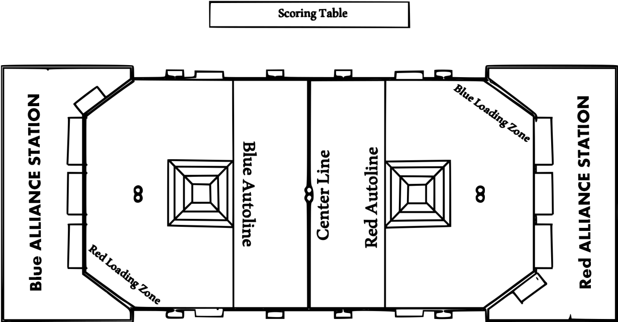­­­­­

Goal

Goals Scored During TeleOp Mode

Feeder

Total Alliance Points

Drive Train

Efficiency of Feeder

1 2 3 4 5 6 7 8 9 10

Driver Capability

1 2 3 4 5 6 7 8 9 10

Scoring Capability

1 2 3 4 5 6 7 8 9 10

Climbing Capability

1 2 3 4 5 6 7 8 9 10

Defense Capability

1 2 3 4 5 6 7 8 9 10

Efficiency of Climber

1 2 3 4 5 6 7 8 9 10

Other Notes(Unique Strategies, Unusual Mechanisms, Problems, etc.

Feeder

Goal

Fouls Received and on what Robot?

Sketch Activity During Autonomous Mode.

Circle all feeder stations used by the robot and write how many times it used that station.

What Height does it feed at?

_______________________

Triangle on where it finished climbing.